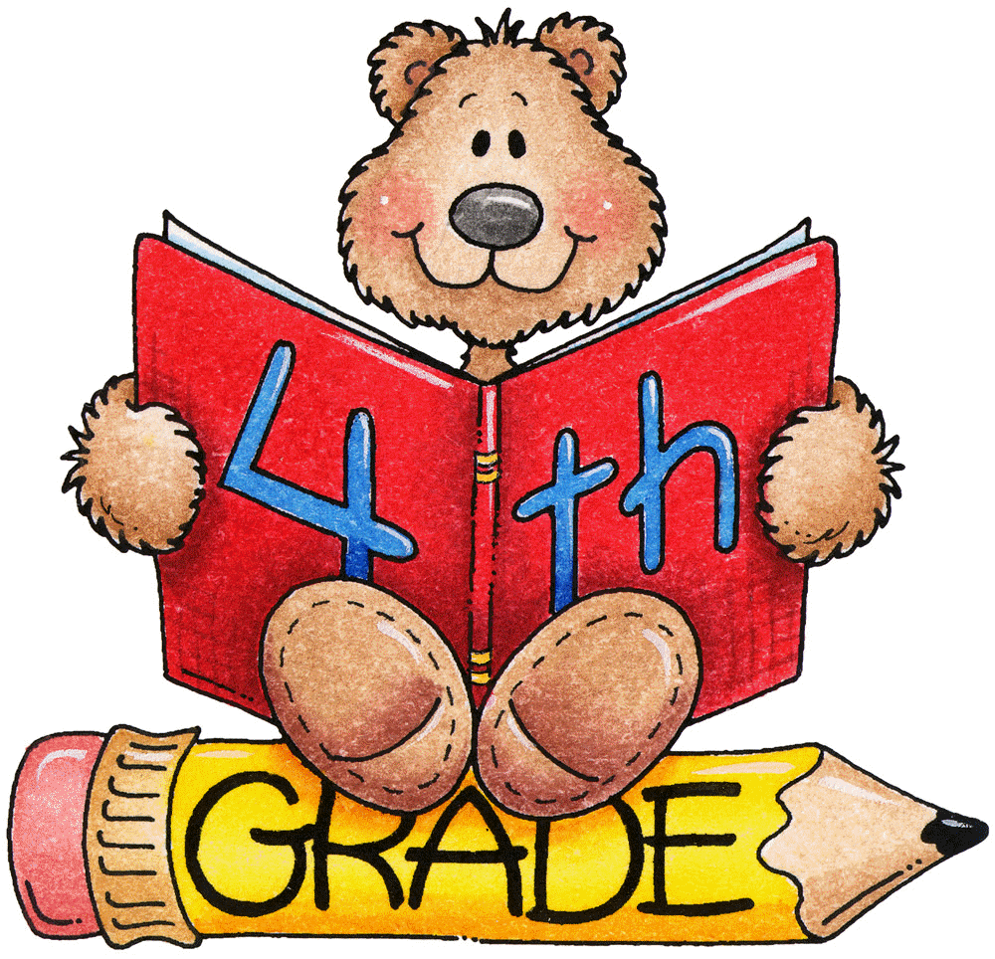

Grade 4

**Standards-Based Report Card**

**Progress Check Points**

*First Nine Week*s

**Science**

All students should know and/or be able to:

* Identify the roles of producers, consumers, and decomposers in a community.
* Demonstrate the flow of energy through a food web/food chain beginning with sunlight and including producers, consumers, and decomposers.
* Predict how changes in the environment would affect a community (ecosystem) of organisms.
* Predict effects on a population if some of the plants or animals in the community are scarce or if there are too many.

**English/Language Arts**

All students should know and be able to:

* Determine a theme of a story, drama, or poem
* Identify author’s purpose in informational and fictional text
* Determine the meaning of words and phrases as they are used in a text
* Analyze how visual and multimedia elements contribute to the meaning
* Read and comprehend texts, including stories, dramas, and poetry on grade level text (Level P/Q)
* Quote accurately from a text when explaining what the text says
* Compare and contrast events over multiple texts
* Explain how an author uses reasons support particular points
* Write opinion pieces on topics or texts, supporting a point of view with reasons
* Write informative/explanatory texts to examine a topic and convey ideas and information clearly
* Write narratives to develop real or imagined experiences or events using effective technique, descriptive details, and clear event sequences

**Mathematics**

All students should know and/or be able to:

* Use strategies involving the four operations with whole numbers to solve problems
* Recognize, understand, and use factors and multiples within 1 to 10, appropriately
* Demonstrate an understanding of prime and composite numbers and use them, fluently, in appropriate mathematical situations
* Understand and use divisibility for common factors
* Generate and analyze patterns, and explain why a rule applies
* Identify and apply understanding of place value for multi-digit whole numbers
* Round multi-digit whole numbers to any place up to 1,000,000
* Use place value understanding to 1,000,000 and properties of operations to perform multi-digit arithmetic
* Develop, discuss, and use efficient, accurate, and generalizable methods of multi-digit arithmetic
* Illustrate and explain calculations using a variety of models and representations
* Demonstrate an understanding of place value through number recognition, comparison, and rounding
* Create numbers that meet specific criteria
* Appropriately use >, =, < symbols to record results of comparisons

**Social Studies**

All students should know and/or be able to:

* Explain and use the 5 Themes of Geography
* Describe cultures of the American Indians
* Describe geography of the American Indians
* Identify physical Features of the US
* Explain European Exploration
* Describe geography of exploration
* Describe character traits of explorers
* Explain the impact of economics on history



Grade 4

**Standards-Based Report Card**

**Progress Check Points**

*Second Nine Week*s

**Mathematics**

All students should know and be able to:

* Understand that a multiplicative comparison is a situation in which one quantity is multiplied by a specified number to get another quantity
* Multiply or divide to solve word problems involving multiplicative comparison
* Solve multi-step word problems with whole numbers having whole-number answers using the four operations including problems in which remainders must be interpreted
* Assess the reasonableness of answers to problems using mental computation and estimation strategies including rounding
* Find all factor pairs for a whole number in the range 1-100
* Recognize that a whole number is a multiple of each of its factors
* Generate a number or shape pattern that follows a given rule and identify features of the pattern that were not explicit in the rule itself
* Use place value understanding and properties of operations to perform multi-digit arithmetic.
* Multiply a whole number of up to four digits by a one digit whole number and multiply two two-digit whole numbers using strategies based on place value and the properties of operations
* Find whole-number quotients and remainders with up to four-digit dividends and one-digit divisors, using strategies based on place value and the properties of operations and/or the relationship between multiplication and division
* Use the four operations to solve word problems involving distances, intervals of time, liquid volumes, masses of objects, and money, including problems involving simple fractions and decimals
* Find areas of rectilinear figures by decomposing them into non-overlapping rectangles and adding the areas of the non-overlapping parts
* Explain why two or more fractions are equivalent by using visual fraction models
* Compare two fractions with different numerators and different denominators by using visual fraction models, by creating common denominators or numerators, or by comparing to a benchmark fraction
* Solve problems involving measurement and conversion of measurements from a larger unit to a smaller unit

**Science**

All students should know and/or be able to:

* Identify external features of organisms that allow them to survive or reproduce better than organisms that do not have these features (for example: camouflage, use of hibernation, protection, etc.).
* Identify factors that may have led to the extinction of some organisms.
* Recognize the physical attributes of stars in the night sky such as number, size, color and patterns.
* Compare the similarities and differences of planets to the stars in appearance, position, and number in the night sky.
* Explain why the pattern of stars in a constellation stays the same, but a planet can be seen in different locations at different times.
* Identify how technology is used to observe distant objects in the sky.
* Explain the day/night cycle of the earth using a model.
* Explain the sequence of the phases of the moon.
* Demonstrate the revolution of the earth around the sun and the earth’s tilt to explain the seasonal changes.
* Demonstrate the relative size and order from the sun of the planets in the solar system.

**English/Language Arts**

All students should know and be able to:

* Determine a theme of a story, drama, or poem
* Identify author’s purpose in informational and fictional text
* Determine the meaning of words and phrases as they are used in a text
* Analyze how visual and multimedia elements contribute to the meaning
* Reads leveled text on rubric with purpose and understanding (Q)
* Quote accurately from a text when explaining what the text says
* Compare and contrast the overall structure of events across multiple texts
* Explain how an author uses reasons support particular points
* Write opinion pieces on topics or texts, supporting a point of view with reasons
* Write informative/explanatory texts to examine a topic and convey ideas and information clearly
* Write narratives to develop real or imagined experiences or events using effective technique, descriptive details, and clear event sequences

**Social Studies**

All students should know and/or be able to:

* Discuss British Colonial America
* Describe geography of the colonies
* Describe federal system of government
* Explain positive character traits of colonists
* Identify and describe causes, events and results of American Revolution
* Describe geography of the Revolution
* Explain the impact of geography on war
* Discuss the Declaration of Independence



Grade 4

**Standards-Based Report Card**

**Progress Check Points**

*Third Nine Week*s

**Science**

All students should know and/or be able to:

* Demonstrate how water changes states from solid to liquid to gas and changes from gas to liquid to solid.
* Identify the temperatures at which water becomes a solid and at which water becomes a gas.
* Investigate how clouds are formed.
* Explain the water cycle.
* Investigate different forms of precipitation and sky conditions.
* Identify weather instruments and explain how each is used in gathering weather data and making forecasts.
* Use a weather map to identify the fronts, temperature, and precipitation and use the information to interpret the weather conditions.
* Use observations and records of weather conditions to predict weather patterns throughout the year.
* Differentiate between weather and climate.

**Mathematics**

All students should know and be able to:

* Continue work and understanding of standard from previous tow nine week periods
* Understand decimal notation for fractions, and compare decimal fractions
* Draw and identify lines and angles, and classify shapes by properties of their lines and angles (including line of symmetry)

**English/Language Arts**

All students should know and be able to:

* Determine the meaning of words and phrases as they are used in a text, including figurative a language such as metaphors
* By the end of the year, read and comprehend literature, including stories, dramas, and poetry at the high end of leveled readers R and above
* Quote accurately from a text when explaining what the text says explicitly
* Compare and contrast the overall structure of events, ideas, concepts, or information in two or more texts
* Explain how an author uses reasons and evidence to support particular points in a text, identifying which reasons
* Write opinion pieces on topics or texts, supporting a point of view with reasons
* Write informative/explanatory texts to examine a topic and convey ideas and information clearly



**Social Studies**

All students should know and/or be able to:

* Discuss the Articles of Confederation, Constitution,
* Discuss the Bill of Rights
* Know the Preamble and “We the People”
* Explain the Federal System of Government
* Know and explain the First Amendment
* Describe the functions of Government
* Explain Democratic beliefs and ideals
* Describe character traits
* Discuss the War of 1812
* Explain ~~the~~ Westward Expansion
* Describe the impact of expansion on population and the resulting changes
* Explain how technology (steamboat, locomotive, and telegraph) impacted life
* Describe Abolition and Suffrage
* Locate features of US
* Identify geography of Westward Expansion
* Describe the impact of economics on history
* Explain World War II
* Identify geographic features of US
* Explain the Cold War
* Identify key people and events 1950-1975
* Identify geographic features of the US
* Identify spatial patterns of economic activity
* Explain citizen’s rights
* Describe the impact of economics on history



Grade 4

**Standards-Based Report Card**

**Progress Check Points**

*Fourth Nine Week*s

**Mathematics**

All students should know and be able to:

* Continue work and understanding of standards from all previous nine week periods
* Solve problems involving conversion of measurements from a larger unit to a smaller unite within the same system
* Solve problems involving measurement including area and perimeter for rectangles
* Create lien plots of measurements expressed in fractions of a unit and solves addition and subtraction problems involving the data presented in the line plot
* Understand concepts of angles and measuring angles
* Sketch angles of a specified measure, find the measure of a specified angle by adding its decomposed parts, and solve addition and subtraction problems to find unknown angles on a diagram in real-work situations

**English/Language Arts**

All students should know and be able to:

* Quote accurately from a text when explaining what the text says explicitly and when drawing inferences from the text
* Determine a theme of a story, drama, or poem from details in the text, including how characters in a story or drama respond to challenges or how the speaker in a poem reflects upon a topic summarize the text
* Determine the meaning of words and phrases as they are used in a text, including figurative language such as metaphors and similes
* Analyze how visual and multimedia elements contribute to the meaning, tone or beauty of text (e.g., graphic novel, multimedia presentation of fiction, folktale, myth, poem)
* Read and comprehend literature, including stories, dramas, and poetry, at the high end of leveled readers S and above, and with the grades 4-5 text complexity band independently and proficiently
* Quote accurately from a text when explaining what the text says explicitly and when drawing inferences form the text
* Compare and contrast the overall structure (e.g., chronology, comparison, cause/effect problem/solution) of events, ideas, concepts or information in two or more texts
* Explain how an author uses reasons and evidence to support particular points in text, identifying which reasons and evident supports which point(s)
* Write opinion pieces on topics or texts, supporting a point of view with reasons
* Write informative/explanatory texts to examine a topic and convey idea and information clearly
* Write narratives to develop real or imagine experiences or events using effective technique, descriptive details, and clear event sequences

**Social Studies**

All students should know and/or be able to:

* Make decisions about spending and saving
* Explain World War II
* Identify geographic features of US
* Explain the Cold War
* Identify key people and events 1950-1975
* Identify geographic features of the US
* Identify spatial patterns of economic activity
* Explain citizen’s rights
* Describe the impact of economics on history

**Science**

All students should know and/or be able to:

* Identify simple machines and explain their uses.
* Using different size objects, observe how force affects speed and motion.
* Explain what happens to the speed or direction of an object when a greater force than the initial one is applied.
* Demonstrate the effect of gravitational force on the motion of an object.
* Identify materials that are transparent, opaque, and translucent.
* Investigate the reflection of light using a mirror and a light source.
* Identify the physical attributes of a convex lens, a concave lens, and a prism and where each is used.
* Investigate how sound is produced.
* Recognize the conditions that cause pitch to vary.